**Wall Art Mural in Charcoal, Stone and White**

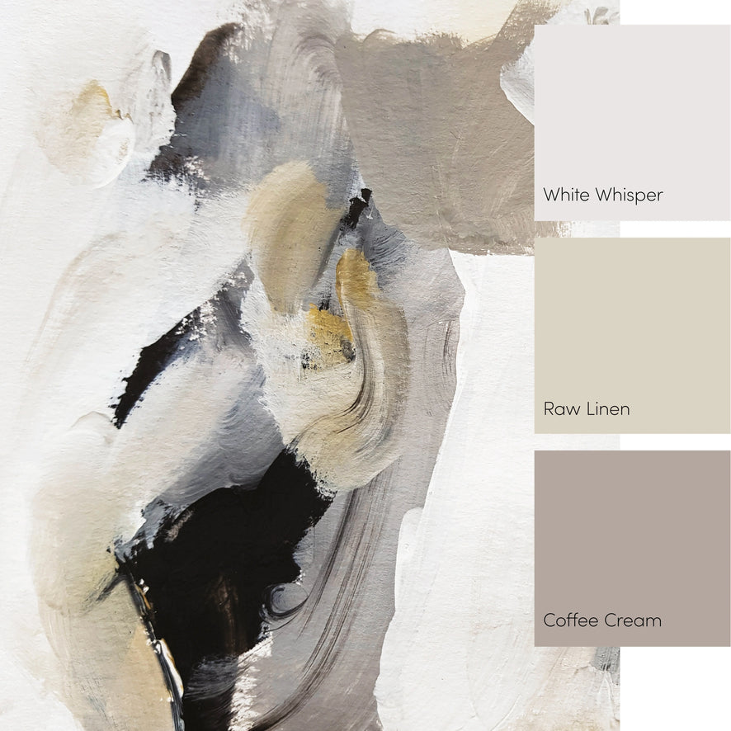A wall art mural in charcoal, stone, and white creates a striking balance of depth and contrast, perfect for making a bold yet elegant statement. The charcoal provides a rich, dramatic foundation, while the stone tones introduce a natural, textured element that adds warmth and dimension. Accents of crisp white bring light and balance, highlighting the details of the design and creating a harmonious interplay of colors. Ideal for modern, industrial, or minimalist spaces, this mural transforms any wall into a captivating focal point, blending sophistication with artistic flair.